1. First of all some tools will be required in order to assembly the pump (Figure 1):
   1. Soldering iron, solder and wire.
   2. Hand saw (It will be needed to cut the Lead screw and the rail)
   3. Sand paper (It will be needed to sand down the sharp edges after cutting the Lead screw and the rail)
   4. Set of screw drivers
   5. Kapton/electrical tape
2. Laser cut the parts in the file [Manufacturing in 5 mm thickness Acrylic.ai](https://github.com/FrancisCrickInstitute/Four_channel_syringe_pump/blob/main/Manufacturing%20files/Mechanics/Adobe%20Illustrator/Manufacturing%20in%205%20mm%20thickness%20Acrylic.ai) which can be found on: <https://github.com/FrancisCrickInstitute/Four_channel_syringe_pump/tree/main/Manufacturing%20files/Mechanics/Adobe%20Illustrator> (Figure 2).

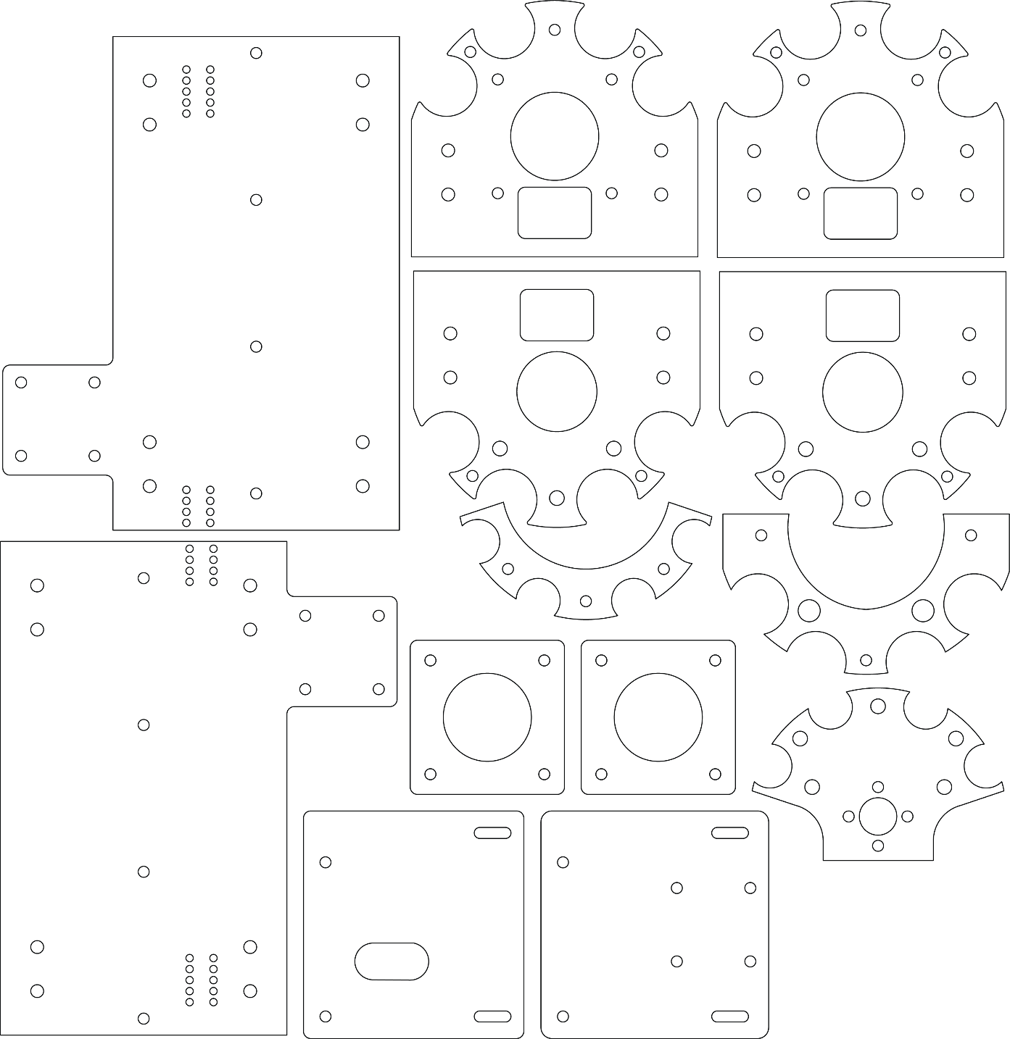

Figure 2: Parts to laser cut.

1. 3D print the parts (Knob.stl, Spacer.stl, Electronics spacer.stl and Nut holder.stl ) found on: <https://github.com/FrancisCrickInstitute/Four_channel_syringe_pump/tree/main/Manufacturing%20files/Mechanics/STL> (Figure 3).

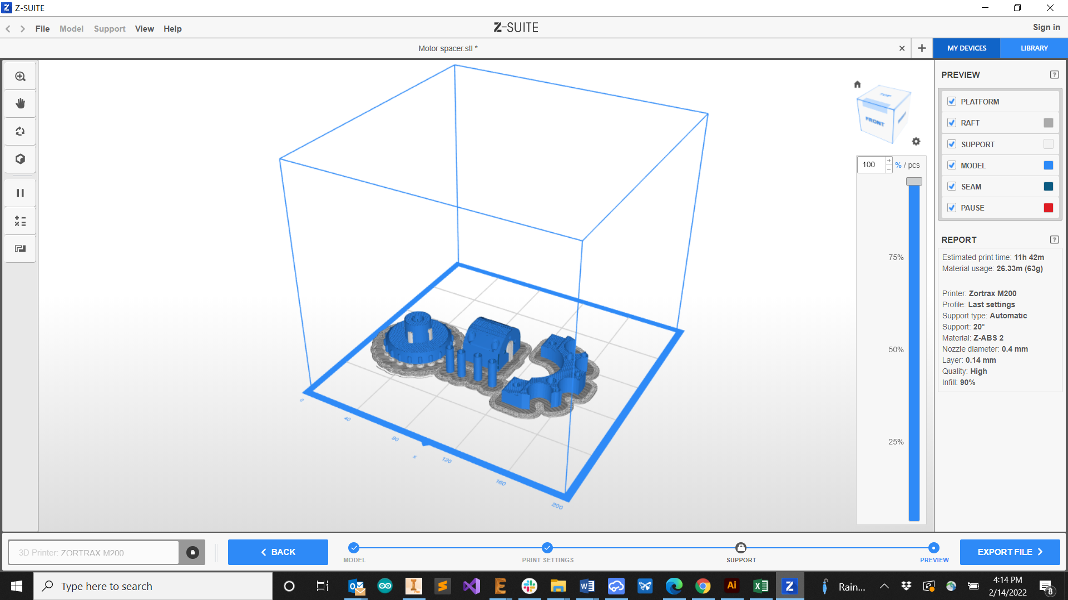

Figure 3: Parts to 3D print on the slicer simulation.

1. Cut the rail with a length of 134 mm and the lead screw a length of X mm using the metal handsaw.
2. Send the electronics to manufacture:
   1. Go to **JLCBPCB**: <https://cart.jlcpcb.com/quote?orderType=1&stencilLayer=2&stencilWidth=100&stencilLength=100>
   2. Upload the Gerber files:

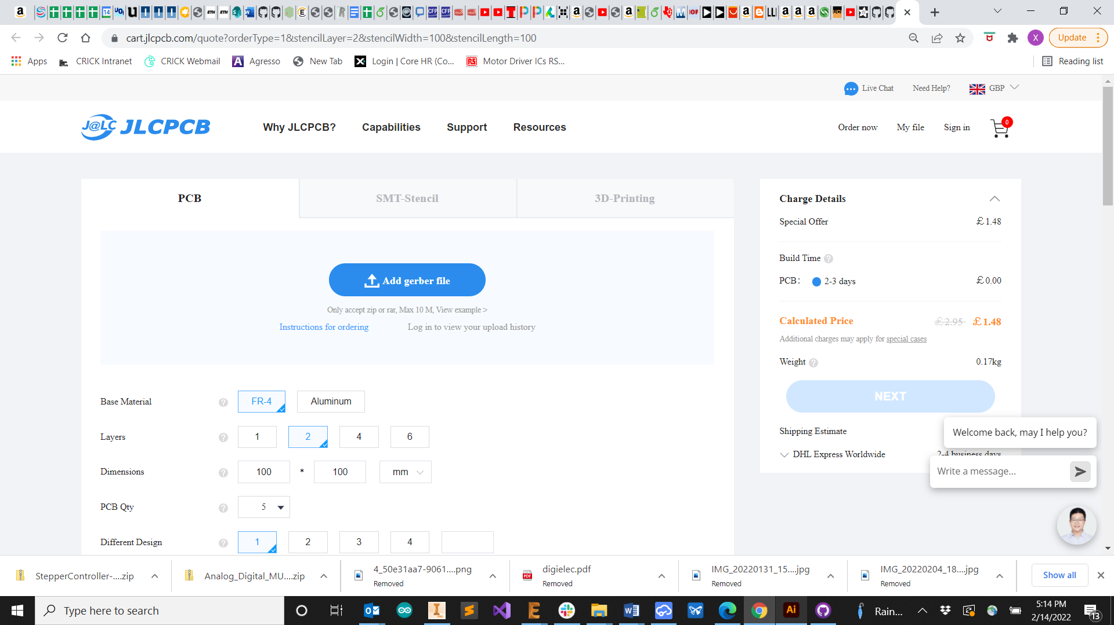

* 1. Scroll down on the same page and Select **SMT Assembly**

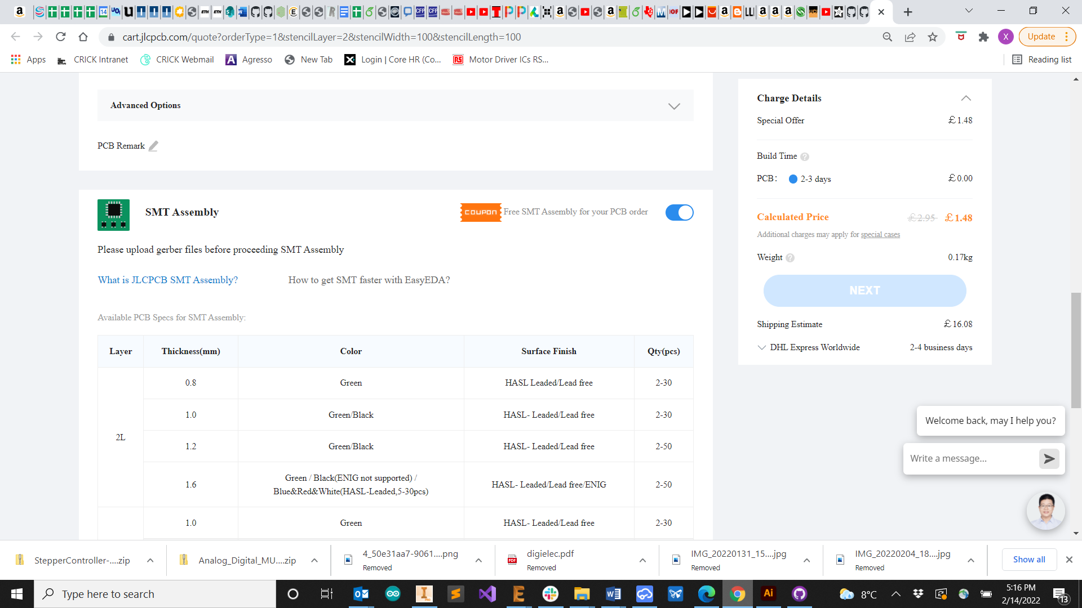

* 1. Upload the BOM file
  2. Upload the Pick and place file

1. Solder the 10k potentiometer on the PCB
2. Solder the Teensy 3.2 on the PCB
3. Add Kapton or electrical tape on the back of the OLED display
4. Solder the OLED display
5. Solder the screw terminals on the motor connectors and Limit switch connectors.

At this point after ordering all the components you should have all the components present in Figure X ready:

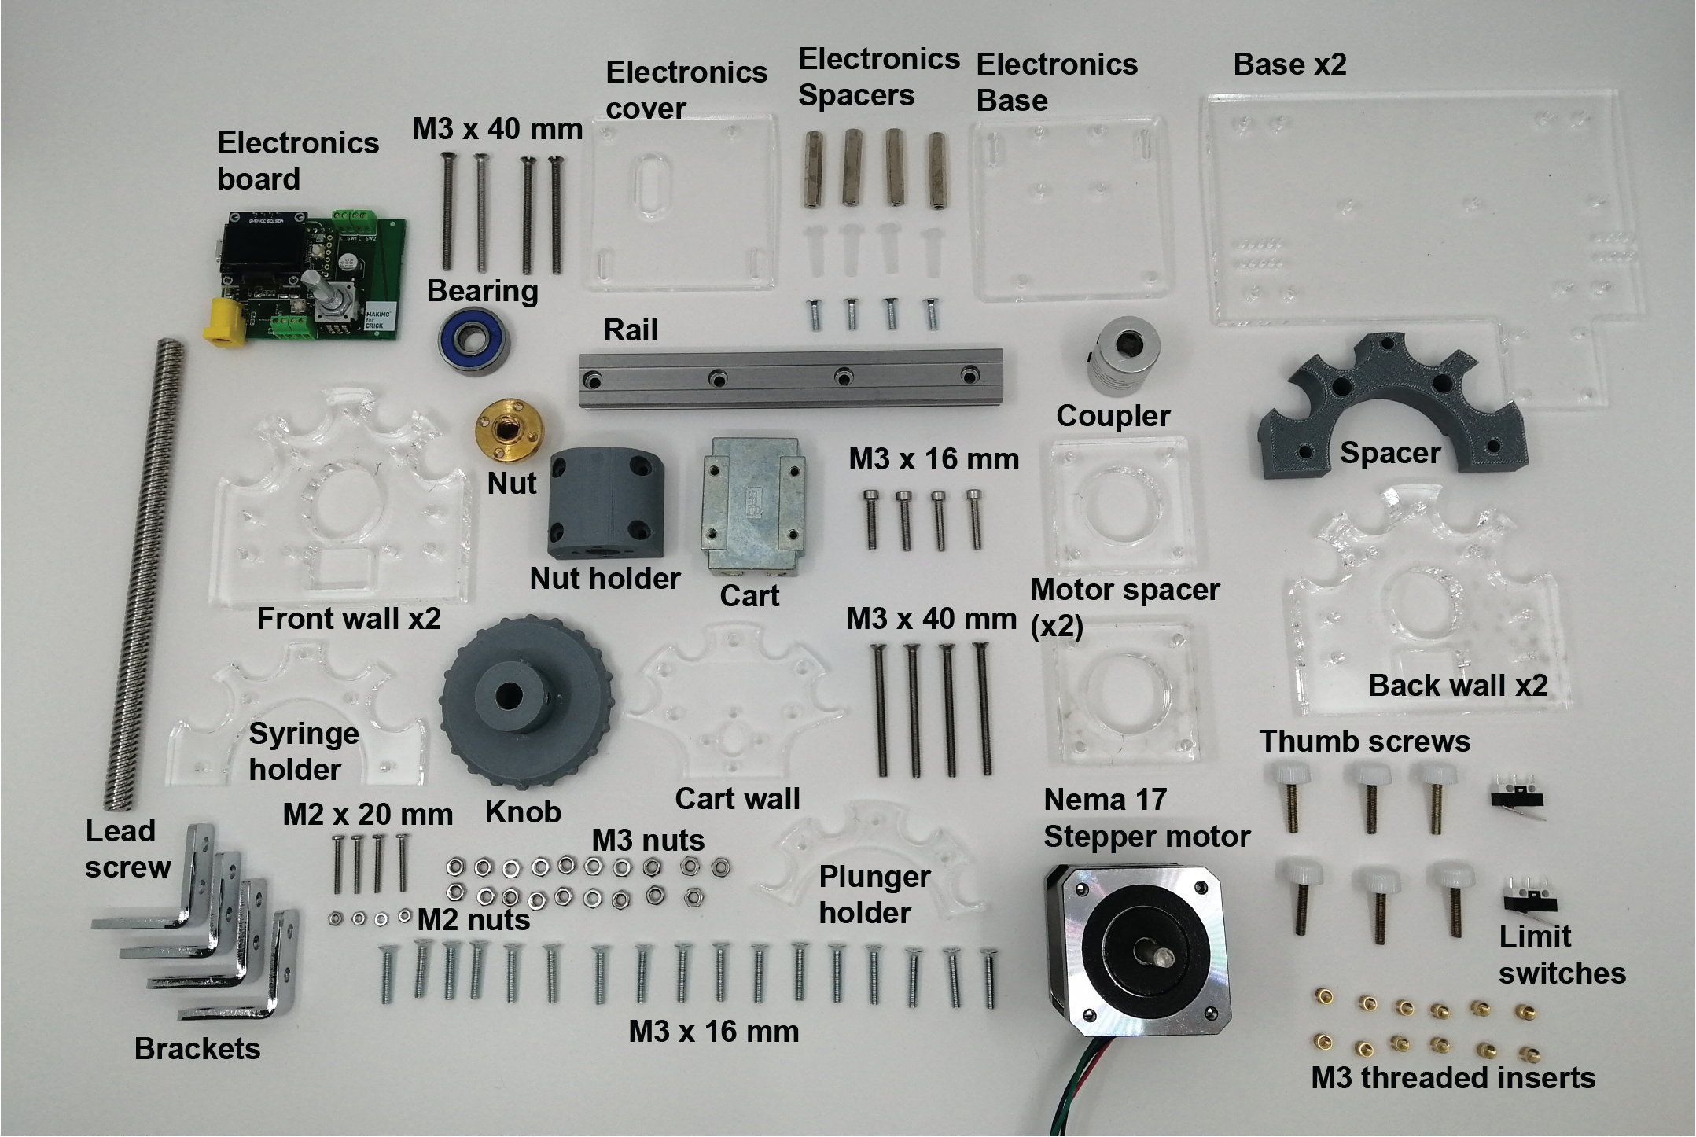

Figure X: Components for the assembly.

1. Cut the stepper motor and limit switch cables at the shortest length and connect them to the screw terminals.
2. Open the Arduino IDE
3. Select the Board Teensy 3.2 in Tools/Board/ “Teensy 3.1/3.2”
4. For Windows computers: Select the COM port in Tools/Port/ COM#(Teensy 3.2)
5. Upload the code [MSTPump_Contstant_flow.ino](https://github.com/FrancisCrickInstitute/Four_channel_syringe_pump/blob/main/Firmware/MSTPump_Contstant_flow/MSTPump_Contstant_flow.ino) which can be found on: <https://github.com/FrancisCrickInstitute/Four_channel_syringe_pump/tree/main/Firmware/MSTPump_Contstant_flow>